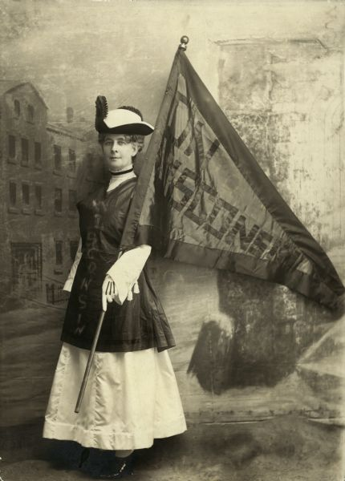

TOUR
GUIDE’S MANUAL:
A WALK THROUGH WOMEN’S HISTORY

TABLE OF CONTENTS
I. Introduction to Leading the Walking Tour 3
II. Tour Map 4
III. Tour Stop Scripts and Resources 5
A. Introduction 5
B. Forward & Wisconsin 6
C. Suffrage and Belle La Follette 8
D. Women in Health and Medicine 10
E. Vel Phillips 13
F. Rosaline Peck 15
G. German Immigration and Mildred Fish Harnack 17
H. Women and Prohibition 20
I. Conclusion 22

INTRODUCTION TO LEADING THE WALKING TOUR
THE WALKING TOUR PROGRAM
The walking tour program currently consists of five walking tours; “A Walk Through Women’s History”, “Hidden History of the Capitol Square”, “A Walk on Madison’s Weird Side”, “Water Obsession: The History of Madison’s Lakes”, and “The Capitol Square Food Tour”. Each of these tours are 90 minutes long and include approximately a mile of walking. They are only offered in the Summer and early Fall and typically no more than three of the walking tour themes are offered in one year.

A WALK THROUGH WOMEN’S HISTORY
This tour was developed to celebrate the centennial of the ratification of the 19th amendment. Each of the tour stops focuses on a movement or an individual who was influential in the history of Wisconsin. These women represent female change makers in this state and how the movements that they supported shaped the perception of women in their era. This tour has nine stops, including the introduction and conclusion. The tour path will stay within the capitol square area, starting and ending at the Wisconsin Historical Museum. The goal of this walking tour is for visitors to leave with an appreciation of the successes and struggles that these Wisconsin women faced and how they ultimately shaped our state’s history.

TOUR MANAGEMENT TIPS
- Make the tour your own: The scripts that are provided in this manual are examples, you do not need to follow them exactly.
- Follow the interests of the group: Each group is unique and getting a sense of their interests will help you shape the tour to follow what the group is hoping to get from it.
- Keep the group together: Maneuvering the capitol square can be difficult with large groups but try to keep the group together when moving from stop to stop. This includes having a staff member or volunteer following at the back of the group to make sure that no one loses the group.
- Do not talk over loud disruptions: Leading tours outside adds the challenge of competing with other noise. Normal traffic levels are easy to talk over but if there is a particularly loud disruption (like a bus, helicopter, or ambulance) wait for it to pass and then continue with your stop. You want to make sure that all of the information that you are sharing can be heard by the whole group.
TOUR MAP

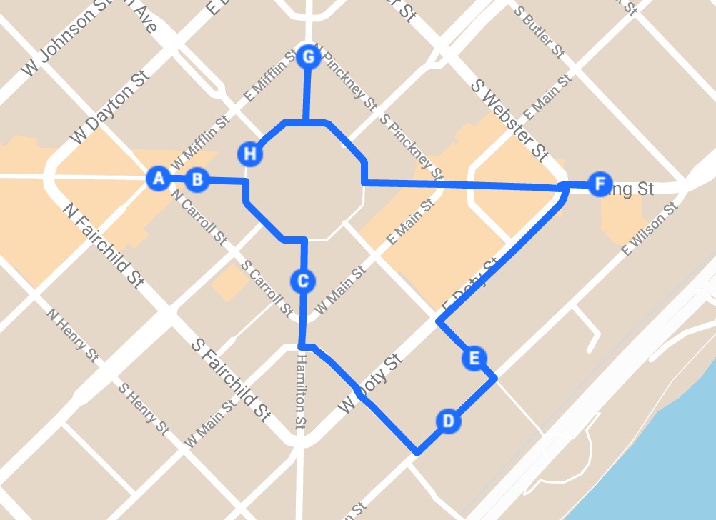
LOCATION DESCRIPTIONS
- Introduction outside of the Wisconsin Historical Museum
- Forward Statue
- Capitol’s south entrance
- Outside of the Wisconsin Department of Health Services
- Near the statue dedicated to the Civil Rights movement
- Historical marker of the Peck cabin
- Capitol’s north entrance
- Looking down State St. toward Bascom Hall

TOUR STOP SCRIPTS AND RESOURCES

INTRODUCTION

Welcome everyone to a Walk Through Women’s History. Today I am going to share with you some stories, from Wisconsin history, of women who have helped to shape our state and our nation. The tour will be about 90 minutes long and we will have walked approximately a mile at the conclusion. Our tour will take us around the capitol square. As we move from stop to stop please try to stick close to the group. I will make sure that we have everyone before I begin every stop. If at any point you cannot hear me, please me let me know. Before we officially begin our tour, I would like to give you a bit of background about why we chose to offer this tour during this summer. This is a historic year in political history because it is the centennial of the ratification of the 19th amendment. As of this August, women will have been able to vote nationally for 100 years. We at the Wisconsin Historical Society have been very excited for this anniversary! You may have seen some of our other celebrations like the “We Stand on their Shoulders” exhibit at the museum or the pop-up exhibit that was in the Capitol rotunda last year. The success of the women’s suffrage movement was a pivotal moment in our history, and we will certainly be talking about that, but there are a lot of other stories of amazing Wisconsin women who have made a difference. Today we will be discussing the stories of women who helped to shape the Wisconsin that we see here today. Please follow me and we can head over to our first stop!

Wisconsin being lifted to the capitol dome.
Jean Pond Miner working on the original Forward statue.

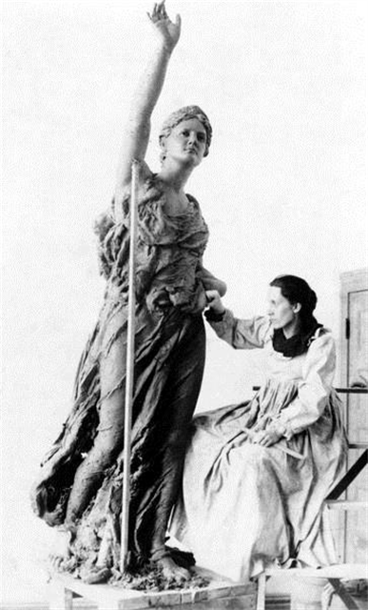
FORWARD & WISCONSIN

The Capitol building depicts women in a number of its architectural features. Probably the most noticeable is the large gold statue (which is actually gilded bronze) on top of the dome, which was designed by Daniel Chester French. That statue is named Wisconsin, she is 15.5 feet tall and weighs over 3 tons. Some of the details that are harder to see from here are the hat that she is wearing, which isn’t a hat at all. It is a badger sitting on her head. She is also holding a globe with an eagle perched on it. Wisconsin has been on top of the capitol since about 1914. There were always plans to have a large statue on the top of the dome when this building was designed but until it could be placed in top of the dome was topped with a large flagpole instead.
The other statue to notice as we pass by the capitol is Forward. Forward was designed by Wisconsin artist, Jean Pond Miner. Miner made the statue for the Wisconsin Women’s memorial at the Columbian Exposition in 1893. Miner was commissioned by the Columbian Exposition to create a piece that represented her state and she chose this design which she felt stood for devotion and progress. Her original design for the statue had it cast in copper but in the process of making this piece the funds ran out and the statue remained in its bronze form. After Forward’s debut at the exposition, she was moved to the East entrance of the Capitol and remained there until 1916 when it was rededicated and moved to the North Hamilton St. entrance. The Forward statue stood outside of the capitol for about 100 years before the wear on the bronze (from being outside in Wisconsin weather) took its toll. It was decided that the statue would have to be moved indoors in order to preserve it. The original Forward statue is now located in the lobby of the Wisconsin Historical Society headquarters building at the end of State St. The original Forward statue was funded in 1893 by Wisconsin women’s groups who provided for the creation and preservation of the statue. This replica was also funded by Wisconsin women as well as the relocation of the first statue.

RESOURCES

“Forward” Statue
This historical essay covers the history of the Forward statue from its creation to its journey over to the Wisconsin Historical Society building.

“Wisconsin” Bronze Statue
Postcard photo of the Wisconsin statue with a description that includes the sculptor and material of the statue.

“Wisconsin” Statue
Photo showing a closer view of the badger and globe that Wisconsin is holding.

Jean Pond Miner and “Forward”
Photograph of Jean Pond Miner working on the “Forward” statue.

Raising “Wisconsin” Statue
Photograph of “Wisconsin” being lifted to the top of the capitol dome.

*Note: ”Wisconsin” is also included in the Capitol Square tour. The script for that tour can be found in the Capitol Square training binder.
An anti-suffrage promotion from the 1912 referendum.
Belle Case La Follette, 1885.

SUFFRAGE AND BELLE LA FOLLETTE
Women have been fighting for the right to vote since the founding of the country, but the suffrage movement took off after the Seneca Falls Convention in 1848. It would take years of protesting and working with male politicians, but women would finally get the vote nationwide in 1920 making this year the centennial of women’s right to vote. There were a number of Wisconsin women who were influential to the suffrage movement including Lavinia Goodell, Theodora Yeomans, Ada James, and many others. One suffragist that operated out of Madison was Belle La Follette. Belle La Follette was very involved in Wisconsin politics. She was the first woman to graduate from the UW law school, doing so after she was married with children. She was married to Robert La Follette who was became the governor in 1901. Together with his wife, who he referred to as his “wisest and best counselor” Governor La Follette pushed new laws that allowed for more rights for women. These laws included limited suffrage which allowed women to vote in school board elections and run for office on the school board. The first opportunity for Wisconsin women to vote in general elections was in 1912. Wisconsin suffragists with support from Senator David James were able to push for a public referendum that would have allowed women to vote in all state elections. Belle La Follette strongly advocated for this referendum through a tour of speeches given around the state. During one 12 day speaking tour La Follette gave 31 speeches in 14 counties. Despite the efforts of the suffragists, the 1912 referendum failed. There was a large amount of opposition from the brewery industry and the church.
After the failed referendum, many suffragists turned their attention to the national movement. The day before President Wilson’s inauguration in Washington D.C. Alice Paul organized a march to push for women’s rights. Belle was scheduled to lead the homemakers’ section of the parade but was not able to make it as she was quarantined with her daughter who had contracted scarlet fever. There were however members of the La Follette family who were present. Three of Belle’s children marched in the rally her oldest daughter Fola and two of her sons Philip and Bob Jr. Though this march was a great statement for the women’s suffrage movement, it also revealed prejudice within the movement. Groups of black women from Illinois came to support the movement and were made to march in the back of the parade rather than with the rest of the Illinois delegation. This is one example of how some of the women’s suffrage movement advocates were unwilling to align themselves with the other equal rights movements despite their shared interests. There are a number of examples where suffrage supporters tried to put down other equal rights movements in order to increase support for their own movement. In response to hearing how the black women from Illinois were treated while trying to show their support for the movement, Belle La Follette stated that she opposed the idea of minimizing one group’s rights in order to enhance another’s.
The fight for suffrage continued until 1919 when a vote was put forward to pass the 19th amendment. This vote was won by only one vote. A Senator from Tennessee, whose political party was opposed to suffrage, was expected to vote against the amendment, but he went against his party and tipped the scales to pass it. On the day of the vote this Senator had in his jacket pocket a letter from his mom telling him to do the right thing. It is important also to note that there was a number of the people in the United States who still were not able to vote.

RESOURCES
The Wisconsin Magazine of History Summer 2019 (Issue available in the museum library)
This issue of the magazine celebrates the centennial of Wisconsin’s ratification of the 19th amendment and includes an article with a thorough look at Wisconsin’s suffrage history.

Fighting Bob La Follette: Righteous Reformer (Book available in the museum library)
This book includes information on Belle Case La Follette’s early life and the political work she did along with her husband and children.

Belle Case La Follette
Photograph of Belle La Follette

Anti-Woman Suffrage Poster

Cordelia Harvey
Betsy Thunder
The Harvey Army Hospital after it was converted into a home for soldiers’ orphans.
Ellen Ainsworth
Cordelia Harvey
Betsy Thunder
The Harvey Army Hospital after it was converted to an orphanage.
Ellen Ainsworth
WOMEN IN HEALTH AND MEDICINE

This building is the Department of Health Services. Though for a lot of our history it was not considered acceptable for women to work in most jobs. One profession that was often something that women were encouraged to pursue, especially during war, and that is medicine. There is a long history of influential Wisconsin women practicing medicine and I will share the stories of three women involved in that field; Betsy Thunder, Cordelia Harvey, and Ellen Ainsworth.
To begin our look at influential women in medicine let’s go back to just after the state was founded. Betsy Thunder was a Ho-Chunk woman born in the 1850s in the Black River Falls area. She married a medicine man who trained her to administer both traditional and ceremonial medical treatments. Thunder became well known in the area for being skilled in medicine. Despite knowing very little English, she treated the white population as well as the Native American population. It was customary for Ho-Chunk healers to receive gifts in return for their service which could include things like food and blankets. One of Thunder’s patients gave her enough lumber to build a cabin in the town of Shamrock and out of appreciation for her work the people of the town built the cabin for her. Thunder continued her healing practice in the Black River Falls area until the early 1900s when the United States government ordered her tribe to move out of Wisconsin and into Nebraska. She was unwilling to leave her ancestral land and hid in the hills of Jackson County, remaining in Wisconsin until her death in 1912. Though we don’t have a lot of recorded information about her life, it is clear that Betsy Thunder made a difference in the lives of those she helped during a time when there would have been limited access to medical care.
Another person influencing the medical field at around the same time as Betsy Thunder was Cordelia Harvey. She was married to Governor Louis Harvey who was only in office for about three months. On a journey back from visiting soldiers after the Battle of Shiloh, Governor Harvey drowned in the Tennessee River. The governor’s goal during this trip was to assess the supplies and conditions at military hospitals where Wisconsin men were being treated and to bring care packages that women had organized from home. After the death of her husband, Cordelia Harvey chose to continue her husband’s work of ensuring safe hospital conditions. She was appointed the State Sanitary Agent by Governor Salomon and travelled South to inspect military hospitals. While at these hospitals she would organize the staff and supply shipments to ensure things were running properly and would give the soldiers the best chance at recovery. After seeing hospital conditions in the South, Harvey began advocating for a hospital to be built here in Wisconsin where soldiers could recover in the familiarity of their home state. She brought her proposal for a new hospital to President Lincoln. At first, he was unsure of the idea because he thought if men were allowed to recover at home they would be less likely to return to their duties and more likely to desert. Harvey convinced him otherwise and the Harvey Army Hospital was built here in Madison. The hospital was so successful that Wisconsin was approved to build two additional soldier hospitals in Milwaukee and Prairie du Chien. After the Civil War, the army hospital was no longer needed in this area. Cordelia Harvey converted the building into a home for orphaned children who had lost their parents during the war. Nearly 700 children lived there during the decade following the Civil War.
The final story I have for you about Wisconsin women in medicine is the heroic work of Ellen Ainsworth. Ainsworth was from Glenwood City, WI. She trained as a nurse and in 1942 enlisted with the US Army Nurse Corp, serving as a second lieutenant in Tunisia and then in Anzio, Italy. During the Battle of Anzio in 1944 the 56th Evacuation Hospital where Ainsworth was working was hit by a German artillery shell. Despite being hit in the chest by a piece of shrapnel, Ainsworth and three other nurses worked to evacuate 42 patients from the hospital and to safety. Six days after the attack Ellen Ainsworth died from her injuries. She is the only Wisconsin woman to die from enemy fire in World War II. After her death she was awarded the Red Cross Bronze Medal, a Purple Heart, and the Silver Star Medal for bravery which is the third highest honor awarded by the military.

RESOURCES

10 Wisconsin Women Overlooked by History
This article includes information on the lives of Betsy Thunder and Ellen Ainsworth.

Harvey, Cordelia (1824-1895)
Essay that details the life of Cordelia Harvey and has a specific focus on her work in medicine.

Betsy Thunder
Photograph of Betsy Thunder

Cordelia A. P. Harvey
Photograph of Cordelia Harvey

Soldiers’ Orphans Home, Farwell House
Photograph of the soldiers’ orphans home that was run by Cordelia Harvey.

Army Nurse Killed in Action
Photograph of Ellen Ainsworth

Vel Phillips advocating for Equal Rights Legislation in the Capitol rotunda.

VEL PHILLIPS

One of the most influential Civil Rights advocates in Wisconsin was Vel Phillips. She was born and raised in Milwaukee and was the first African American woman to graduate from the UW law school. She was also the first woman and the first African American to be elected into the Milwaukee common council. As a Milwaukee alderperson, one of Phillips’ main goals was to address the unequal housing laws in the city and to pass a fair housing act. Milwaukee had been segregated for decades with black families living in one area in the north of Milwaukee and not able to move into other neighborhoods. Vel Phillips first brought fair housing legislation to the Common Council in 1962 and for five years to reintroduce it each time it was turned down. She also worked with Father Groppi, a white Catholic priest, and the NAACP to organize demonstrations in Milwaukee urging the city to introduce equal rights legislation. The first march that they led had 100 demonstrators who marched out of the Milwaukee ghetto and into a white neighborhood. They were met with 5,000 protestors who yelled and threw things at them. Two nights later they held another march through a white neighborhood and were met by 13,000 people yelling threats and racial slurs. On the same night as this second march, the NAACP headquarters building was burnt down. The mayor issued an order against any further demonstrations in order to avoid further violence. The leaders of the movement, including Vel Phillips were arrested. Despite the order Phillips, Father Groppi, and the NAACP continued their efforts and lead an additional 200 nights of non-violent protesting and eight months of lobbying. The largest demonstration that they had organized was a march through the city after the death of Martin Luther King Jr. King had previously sent a letter to the protestors in Milwaukee giving them his support. The non-violent protests of the movement were based on what King was doing in the South. The demonstration after King’s death was the largest in the history of the city, 15,000 people marched through Milwaukee. A week later the Civil Rights Act was signed and rather than go against a federal law, the city had to pass the open housing ordinance.
After 15 years as an alderperson, Vel Phillips resigned her position and became the first female judge in Milwaukee and the first African American judge in Wisconsin. In 1978 she was elected Wisconsin Secretary of State which made her the highest-ranking woman to win state office in the 20th century. Though she had achieved this high office, she still faced challenges in her job. There was one point during her term when both the governor and lieutenant governor were absent, making Phillips the acting governor. She acted in that position only briefly, because as she noted, “the men hurried back” when they realized they had left a woman in charge.

RESOURCES

Vel Phillips Receives 2006 ‘Robert and Belle Case La Follette Award for Distinction in Public Service’
Article including information of Phillips’ early political career and the protest-era work that she did in Milwaukee.

Martin Luther King and Wisconsin
Historical essay of Vel Phillips and Father Groppi’s work and how Martin Luther King Jr.’s efforts helped them to form their own peaceful protests.

Vel Phillips’ Common Council Desk
A curator’s favorites article about the desk that Vel Phillips used while on the Milwaukee Common Council. This article also includes information about Phillips’ efforts as an alderperson to change Milwaukee legislation and covers the protest history of the Civil Rights movement in Milwaukee.

Vel Phillips
Photograph of Vel Phillips in the Wisconsin capitol.

Rosaline Peck

ROSALINE PECK

Rosaline Peck and her husband Eben owned the Peck Cabin, the first boarding house in Madison. They came to Madison shortly after the city was declared the territorial capitol. Their boarding house served travelers to the area as well as the legislators and construction workers who were building the first Madison capitol building. The Peck Cabin served as the town’s boarding house, post office, event venue and whatever else the people of Madison needed. It was also well known for having fantastic parties and gatherings. Mrs. Peck was the life of the party because she was a talented violin player and could provide good music for all of their festivities. The Peck’s hosted a many of Madison’s firsts including our first Thanksgiving, our first wedding (which Mrs. Peck provided the music for and also presided over as the justice of the peace), and the first New Years Eve party which reportedly lasted for two day and two nights. The Pecks stayed in Madison for about two years before moving to Baraboo with their children. Shortly after that in the 1840s Rosaline’s husband left her and the family to go West. He never returned. Rosaline Peck was left to care for and support her family on her own while living in the frontier that Wisconsin was at the time. Years later in the 1860s a Baraboo newspaper wrote an article with a less than flattering portrayal of her boarding house in Madison. Peck felt that she was not given credit for her role in helping to establish early Madison and would later write a poem to the people of Madison which reads:

“Ho Madison:
And its once starved and hungry crew,
With stomachs expanded so wide,
Who, now, in their pride, can gulp down their stew,
And Oysters, and turkeys beside.They should
Look back a few years and remember their mother,
Who perspired to give them relief
And have charity more for sister and brother
Whilst gorging their pie, cakes and beef.”

So I would like to give Rosaline Peck credit for helping to establish that early Madison community and for providing food, care, and fun to those early Madison settlers.

RESOURCES

Rosaline Peck’s Violin
Curator’s favorites article that focuses on life in the early Madison settlement. Includes information on Rosaline Peck’s cabin and the festivities that were held there.

Mrs. Rosaline Peck
Photograph of Mrs. Peck

*Note: Rosaline Peck is also included on the “Hidden History of the Capitol Square” tour and though that tour will tell a different story about her life, the script for that tour would be a good resource for more background information on her. The script for that tour can be found in the Capitol Square Walking Tour training binder.

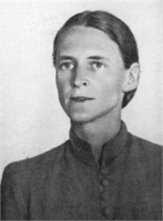
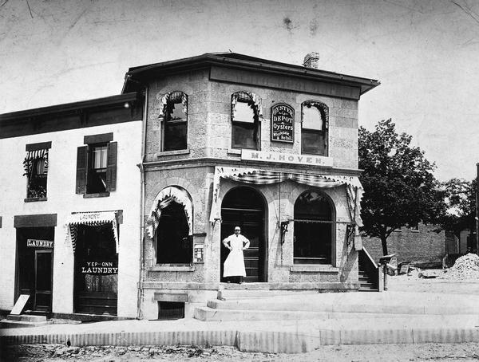
M. J. Hoven’s butcher shop on the capitol square
Mildred Fish Harnack

GERMAN IMMIGRATION AND MILDRED FISH HARNACK

Wisconsin’s immigration history has shaped many of the aspects that we now associate to being essential parts of our state’s identity. It became common for immigrant families from primarily western Europe to move into this area in the mid 1800s. Before I tell you the story of European immigration to the area, it is important to recognize that the increase in immigration would also result in many of the Native Nations, who were already here, being forced to move to other areas. Some of the Native Nations who were living in this area had already been removed from their ancestral land further East and there were some who had lived in this area throughout the history of their Nation. In the Madison area, the Hochunk nation was here prior to European settlement. They were recognized as a sovereign nation and held 8 million acres of land. The Hochunk were forced to sell their land and leave. They were first moved to Iowa, then Minnesota followed by South Dakota and finally to a reservation in Nebraska. The United States government wanted the land that the Native Nations owned in this area primarily because it provided the opportunity to expand the lumber, farming, and mining industries.
One of the European immigrant groups to make a large impact on Wisconsin’s culture were people coming to the area from Germany. We can see examples of their influence all over the state including everyone’s favorite tailgate food, the brat. This is a great area to talk about German immigration history because right across the street would have been a German-owned butcher shop. This butcher shop was a social hub at the time where you would go to talk to other community members and catch up on the local news and gossip. Here we will talk briefly about the reaction in Wisconsin to German immigration and then I will tell you the story of Mildred Fish Harnack.
German immigrants first started moving to Wisconsin in the 1850s due to an immigration initiative by Governor Farwell that sent advertisements to Germany about settling in Wisconsin. When they first arrived, many of the German immigrants were met with a culture clash with other settlers who had already been here. The primary issue was centered around alcohol and whether or not Madison should be a dry city.
German immigrants continued to come and shape the cities of Wisconsin. Milwaukee especially experienced a lot of German influence. That is also where Mildred Fish was born and raised in a primarily German community. As a child she learned how to speak, read, and write in both German and English. She would also have been exposed to some of the prejudice that German communities in Wisconsin endured during and after World War I. She attended the University of Wisconsin-Madison and worked her way to a masters degree. She was very interested in literature and that remained a passion of hers throughout her life. While at the university she met Arvid Harnack, a visiting professor from Germany. The two got engaged at Picnic Point and were married shortly before Arvid moved back to Germany. A year after her husband returned to his home country, Mildred would move there and the couple settled in Berlin in 1930. Three years later the Nazi party would have control of Germany. The Harnacks were not in agreement with the principles of the Nazi party and they helped to form a resistance group called the Red Orchestra. They and the other members of the organization would feed information from Germany to the United States and the Soviet Union. They warned the Soviet Union of a coming attack on Stalingrad before the German army was able to reach the city. That battle resulted in heavy losses for Hitler’s army. The organization operated for about two years before their radio signals were intercepted and they were discovered. Mildred and Arvid were among the members of the organization to be arrested for their involvement. They were both tried in December 1942 for espionage and both were found guilty. Arvid was sentenced to death and was executed on Christmas Eve. Mildred was first sentenced to serve four years in a prison camp, but Hitler wanted her retried with a harsher punishment. She was given another trial with no new evidence presented and sentenced to death. She was executed in February of 1943. Her heroic sacrifice was recognized by the people of Wisconsin. The state named September 16th the day to honor Mildred Fish Harnack and her contribution to her home country’s efforts during WWII.

RESOURCES

Germans in Wisconsin
Information about German immigration into Wisconsin in the 1800s and early 1900s.

19th Century Immigration and Growth
Information on Wisconsin’s general immigration history.

Ho-Chunk Nation
A page from the Department of Public Instruction on the history of the Ho-Chunk nation, including the era of forced removal.

Harnack, Mildred Fish 1902-1943
Historical essay with a summary of the impact that Mildred and Arvid Harnack had on World War II.

Honoring Mildred Fish Harnack
A 3-part collection of essays on the life of Mildred Fish Harnack from her early life and university years through her death.

From Literary Scholar to Soviet Spy
Summary of Mildred Fish Harnack’s life with information on how the Red Orchestra operated and were caught.

M. J. Hoven’s Meat Market
Photograph of Hoven’s butcher shop.

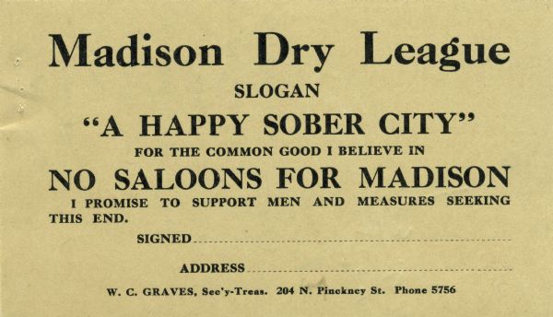
A card from the Madison Dry League showing support for the movement to make Madison a dry city.

WOMEN AND PROHIBITION

I have shared a number of stories about the accomplishments of women in this state. For this stop I have a story about something that women actually didn’t do but it is often attributed to them. I talked a little bit about the issues that the state was having with deciding how Wisconsin was going to handle legislation around the production and sale of alcohol. Suffrage and temperance are often movements that are associated with one another and many suffragists also supported temperance. The view of women as general supporters of temperance is part of the reason that the 1912 referendum for women’s votes did not pass. The brewing industry was strongly opposed to women getting the right to vote because they thought that women would then vote for legislation that banned alcohol sale or production. The brewing industry was correct in their prediction that the sale of alcohol would be banned, but this actually occurred before women had the right to vote. The 18th amendment, which started the prohibition era, was passed about a year prior to women getting the national vote. That is not to say that women were not involved in getting that legislation created and passed. Many women’s suffrage groups, though certainly not all, were supporters of temperance and the prohibition movement but this issue was mainly a clash of cultures between those who were coming to Wisconsin from New England and those who were coming from Germany. New England had a strong prohibition culture which went against the brewing industry that was taking root here and was connected largely to German immigration.

RESOURCES

The Woman’s Suffrage Movement
Brief explanation of the connection between the women’s suffrage movement and the temperance.

Temperance Movement in Wisconsin
History of the temperance movement focusing on a few of the influential groups who were promoting the movement

Prohibition
Background on the prohibition movement and the passing of the 18th amendment.

Madison Dry League Card
Photograph of the Dry League card

*Note: The tour guide enrichment for the Suffrage Exhibit includes a section on the connection between suffrage and prohibition. That information can be found in the Tour Guide Enrichment files.
CONCLUSION

This brings us to our final stop. We have discussed a number of Wisconsin’s influential women and the impact that they have had on our state and our nation. Our tour has covered a long range of time, with stories going back to territorial Wisconsin. Each of the women in this tour represents a change maker in our history, and there are countless more influential women who I didn’t mention but made a huge difference in all of our lives. I hope that you have enjoyed learning about these interesting women. I would like to conclude our tour by wishing you all a happy centennial of women’s voting rights.

REFERENCES

Anti-Woman Suffrage Poster. Wisconsin Historical Society. https://wisconsinhistory.org/Records/Image/IM1932.
Army nurse killed in action. Wisconsin Historical Society. https://wisconsinhistory.org/Records/Image/IM99328.
Belle Case La Follette. Wisconsin Historical Society. https://wisconsinhistory.org/Records/Image/IM3841.
Betsy Thunder. Wisconsin Historical Society. https://wisconsinhistory.org/Records/Image/IM4492.
Cordelia A.P. Harvey. Wisconsin Historical Society. https://wisconsinhistory.org/Records/Image/IM36009.
“Forward” statue. Wisconsin Historical Society. https://wisconsinhistory.org/Records/Article/CS2752.
From literary scholar to soviet spy. Wisconsin Historical Society. https://www.wisconsinhistory.org/Records/Article/CS4367.
Germans in Wisconsin. Wisconsin Historical Society. https://wisconsinhistory.org/Records/Article/CS2041.
Harnack, Mildred Fish 1902-1943. Wisconsin Historical Society. https://www.wisconsinhistory.org/Records/Article/CS8505.
Harvey, Cordelia (1824-1895). Wisconsin Historical Society. https://wisconsinhistory.org/Records/Article/CS1620.
Ho-Chunk nation. Wisconsin Department of Public Instruction. https://dpi.wi.gov/amind/tribalnationswi/ho-chunk.

Honoring Mildred Fish Harnack. University of Wisconsin-Madison Archives and Records Management. https://www.library.wisc.edu/archives/exhibits/campus-history-projects/honoring-mildred-fish-harnack/.
Jean Pond Miner with “Forward”. Wisconsin Historical Society. https://wisconsinhistory.org/Records/Image/IM10592.
Madison Dry League Card. Wisconsin Historical Society. https://wisconsinhistory.org/Records/Image/IM87237.
Martin Luther King and Wisconsin. Wisconsin Historical Society. https://wisconsinhistory.org/Records/Article/CS253.
M.J. Hoven’s meat market. Wisconsin Historical Society. https://wisconsinhistory.org/Records/Image/IM11037.
Mrs. Rosaline Peck. Wisconsin Historical Society. https://wisconsinhistory.org/Records/Image/IM38795.
Prohibition. Wisconsin Historical Society. https://wisconsinhistory.org/Records/Article/CS1962.
Raising “Wisconsin” Statue. Wisconsin Historical Society. https://wisconsinhistory.org/Records/Image/IM9566.
Rosaline Peck’s violin. Wisconsin Historical Society. https://wisconsinhistory.org/Records/Article/CS2747.
Soldiers’ orphans home, Farwell House. Wisconsin Historical Society. https://wisconsinhistory.org/Records/Image/IM10028.
Temperance movement in Wisconsin. Wisconsin Historical Society. https://wisconsinhistory.org/Records/Article/CS1996.
The woman’s suffrage movement. Wisconsin Historical Society. https://www.wisconsinhistory.org/Records/Article/CS419.
Unger, N. J. (2019). Belle La Follette’s fight for women’s suffrage: Losing the battle for Wisconsin, winning the war for the nation. Wisconsin Magazine of History, 102(4), 28-41.
Unger, N. J. (2000). Fighting Bob La Follette: The righteous reformer. The University of North Carolina Press.
Vel Phillips. Wisconsin Historical Society. https://wisconsinhistory.org/Records/Image/IM28114.
Vel Phillips’s common council desk. Wisconsin Historical Society. https://wisconsinhistory.org/Records/Article/CS2700.
Vel Phillips receives 2006 “Robert and Belle Case La Follette Award for Distinction in Public Service”. Wisconsin Historical Society. https://wisconsinhistory.org/Records/Article/CS542.
“Wisconsin” bronze statue. Wisconsin Historical Society. https://wisconsinhistory.org/Records/Image/IM31922.
“Wisconsin” Statue. Wisconsin Historical Society. https://wisconsinhistory.org/Records/Image/IM35542.
10 Wisconsin women overlooked by history. Wisconsin Historical Society. https://wisconsinhistory.org/Records/Article/CS16291.
19th century immigration and growth. Wisconsin Historical Society. https://wisconsinhistory.org/Records/Article/CS3668.

