Catch the Bananas:

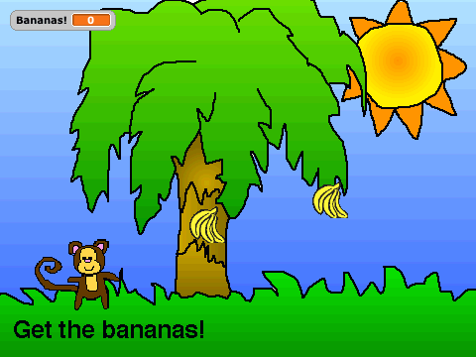
In this lesson, you’ll make a game in which the user controls a monkey; when the user presses the arrow keys, the monkey runs across the screen, trying to catch bananas that are falling from a tree. Every time the monkey catches a banana, he gets a point.

You will learn about if statements and variables. An if statement asks a question and then executes some code if and only if the answer to the question was true. With an if statement, your program can ask if the monkey catches the banana; if it does, then the code can increment the number of points the monkey has. A variable is a way for your program to remember something. In this game, the number of points (or, the number of bananas the monkey has caught) is stored in a variable.

This lesson has three steps:
- Make the monkey walk when user presses an arrow key.
- Make bananas fall from the tree (from random locations and moving at random speeds)
- Check if the monkey catches the banana; if it does, increment the number of points.

We’ll be using a Monkey as our main character in this game, but you can use any Sprite that you like. You will want to pick a Sprite that has two different costumes (like the cat that Scratch starts out with) so you can make it look like your character is really walking. The Sprites with two different poses are named something like animal-a and animal-b. Make sure you import one Sprite and give it two Costumes.

Make Monkey Walk
We first want the user to be able to control the monkey by pressing the left and right arrow keys on the keyboard. When the user presses the left arrow key, the monkey should move to the left; when the user presses the right arrow key, the monkey should move to the right.

To make the monkey move right, combine the point in direction 90 block with the move 5 steps block. How should you then activate that script? The easiest way is to use the When right arrow key pressed Control block. Try this out. You can make the monkey left similarly: combine the point in direction -90 with the move 5 steps block and activate it with the When left arrow key pressed Control block.

Right now, the monkey just looks like he is sliding to the left and right; he doesn’t look like he is walking. To make it look like he is taking steps, you can tell the Monkey to switch costumes every time he moves. Try inserting the block next costume after the move blocks. Remember to do this for both left and right directions!

Monkey Scripts: Easy Version
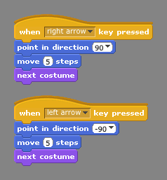

Make Bananas Fall
You now need to choose an object that you want the Monkey to catch. We’ll assume you import a banana Sprite, but you can pick any object you like. We’ll start by writing the code for only one group of bananas; once we get this code perfect, we’ll copy the Banana Sprite so we have many of them falling from the tree.

Lets pick a place where you want the bananas to fall from. Pick any x and y position you want for now. When the Green Flag is clicked, you should make the bananas go to this x and y position. Now, what should happen? The bananas should fall down. To make the bananas go downwards, should their x or their y position change? It is their y position. Should y get bigger or smaller? Smaller.

We’ll use a new Motion block to make the bananas move in this game. You can tell the bananas to move down with the Motion block change y by -5. You want the bananas to keep moving down forever. Try this out.

Now, what should happen if the bananas make it all the way down to the bottom of the screen and the monkey misses it? Let’s make the bananas go back to their starting x and y position so it looks like another set of bananas are falling. But how are we going to find out if the bananas are on the edge of the Stage?

Previously, you learned that you could use the if on edge, bounce command to make the Sprite turn around. This time, we still want to test if the bananas are on the edge, but this time, instead of bouncing, we want the banana to execute the block go to x: y:. We can do this with the if control block. The if block lets you ask lots of different questions and if the answer to that question is true, it then runs the blocks inside.

The questions you can ask as part of an if are the same ones you could ask for the repeat until control block we saw in Lesson 3. There are lots of interesting questions under the Sensing Menu. The question we want now is touching edge? If the answer is true, the banana should then go to x: y:. We should ask this question after every time we change y. Try this out.

Now, we want the bananas to be able to be caught by the monkey. So, lets make the bananas also ask the question “Is the monkey touching me?” You can find this question under Sensing too. If the monkey touches the bananas, lets make the bananas go back to their starting x y position so it looks like it is another set of bananas falling.

Of course, right now the game is too easy because the bananas always fall from the same place. We would like the bananas to start at some unknown, random position each time. Scratch can pick a random number for you with the pick random block under Operators. You’ll want to pick the minimum and maximum values you pass to pick random carefully. You will then use the answer (or the output) that this block gives as the input to the go to x: <random> y: <random> block. You should figure out x and y ranges that make sense in your game. For example, for the Monkey game, the bananas should look like they are falling from the top of the tree, not from the sky or the sun!

You can make the game a little more interesting by making the speed at which the bananas fall random too. To do this, put pick random as the amount to change y by. I like y values between 0 and -5.

Give Points for Catching Bananas
We want the Monkey to get points for each of the bananas that he catches. We need the game to remember how many points the Monkey has and give him more points every time the Monkey catches the bananas.

Points are an example of a Variable. Variables are used any time you need your program to remember something for you. Under the Variable Menu, click on Make a variable, and give the variable a good name like Points or Bananas! Make sure that the option For all Sprites is selected; this means that all Sprites can see and use this same variable. If the checkbox is marked next to the variable name, then that variable will be displayed on the Stage; we want the user to see their points, so make sure it is checked.

Whenever you have a variable, you need to always decide how that variable should be initialized (or what value it should have when the game starts up). How many points should the Monkey have when the game starts? Probably zero. A good place to put initialization code is with the Stage. Use the block set Points to 0 and run that block When the Green Flag is Clicked.

When should we increment the number of Points the Monkey has? Whenever the Bananas are touching the Monkey. Within the if statement you already have, before you tell the bananas go to x: y: insert the block change Points by 1.

Lets try this out. It should look great! Now that you have the correct Scripts for the bananas, you can now duplicate the banana Sprite to make the game more interesting. Copy the Banana Sprite as many times as you like! Each banana sprite will be running this code, and picking its own random numbers.

4) Optimize your code
Advanced: Your code works fine as it is, but you may have noticed that the Monkey moves a little slowly. If this bothers you, you can make the Monkey move faster by changing the instructions you give it.

Instead of starting up a new script each time the user presses an arrow key, your program will be more efficient if you keep the script always running and periodically check if the user is pressing the left or right arrow keys. Change your Monkey scripts so that When the Green Flag is Clicked, the monkey asks if the right arrow key is pressed; if it is, it moves right just as before. The monkey should then ask if the left arrow key is pressed; if it is, it moves lefts just as before. The monkey will need to keep asking these questions over and over again so put the questions inside a forever loop.

Things to Remember
There are many ways to move sprites. In this lesson, you saw you can make a Sprite move up and down with the block change y by.

An if statement asks a question and then executes some code if and only if the answer to the question was true. With an if statement, your program can ask questions about what is happening and then react to the current situation. There are many interesting questions your Sprites can ask; most are under the Sensing Menu.

A variable is a way for your program to remember something. A variable holds a value for you; this value can change (it can vary) as your program runs. You should name your variables with something descriptive so you can remember what it means. You can show the value of a variable by checking the box next to its name. Variables should always be set (or initialized) to some value when the program starts (that is, when the Green Flag is Clicked). A logical place to initialize variables that are shared across all Sprites is with the Stage.

Final Scripts: Monkey
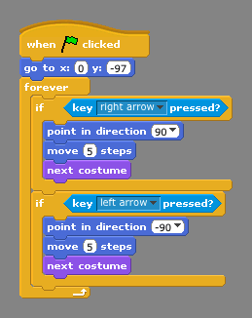

Final Scripts: Banana
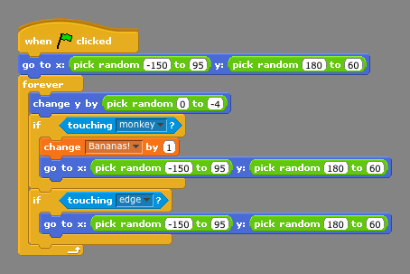

Final Scripts: Stage
