Pen Art: Gliding around the Stage
Note to Instructor: This lesson intentionally involves only a single Sprite and a single Script so that students understand the basics of sequential code first. Control structures are kept to a minimum.
Available at http://scratch.mit.edu/projects/dusseau/2801700
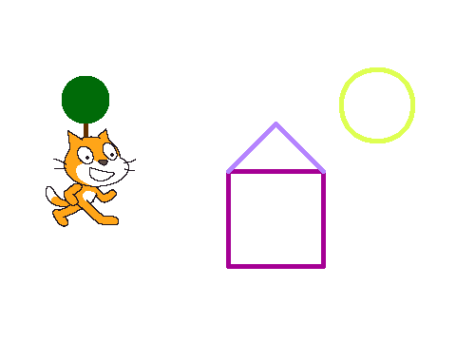
In this lesson, we will draw shapes using the Pen in Scratch. You will learn how to use the (x, y) coordinate system to describe positions on the Stage, how to make a Sprite glide around the Stage, and how to draw with the pen.

This lesson has five simple steps:
- Change the background, or stage, to show the x-y coordinates
- With the Pen Down, move the cat in the shape of a square
- Move the cat in the shape of a triangle
- Draw a tree
- Draw a circle (for the sun)

Change the background, or stage
It is very easy to change the background in Scratch. In Scratch, the background is actually called the Stage. It works a lot like a sprite because it can have costumes, scripts, and sounds too. To edit the Stage, you need to first select it.
Click the Backdrop tab to see the backgrounds. You can draw your own background or import one that is already made.

We are going to start with an educational stage: one that shows the (x,y) coordinate system. Click the Import Button. A window will pop up that will allow you to choose a background. Choose the xy-grid. You should see the new background in your world!

Every Sprite has a position on the Stage. The vertical position (up and down) of each sprite is called y; the horizontal position (left and right) is called x. The current y position of a sprite is stored in a variable called y position; the current x position of a sprite is stored in a variable called x position.

You can find these variables under the Motion menu.
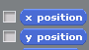
If you click on their boxes, their values will be shown in the World window.
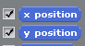
Move your Sprite around the Stage and watch the x position and y position variables change…

Draw a square
Let us make our Sprite glide to a new position on the stage. We can do this with the glide command which is under the Motion menu. Glide takes 3 numbers as inputs (or parameters or arguments): the amount of time it should take to move the Sprite to the new position, the new x position, and the new y position.
To move the Sprite to the middle of the Stage, what x and y value should you specify? This will be the first corner of your square.

To move the Sprite to the top of the Stage, what x and y values should you use? To the bottom? To the far left? To the far right? To the upper left corner?

(SHORTCUT: One way is to fill in those numbers by hand using your knowledge of the x,y coordinate system. This is fine, but sometimes it can be a little difficult figuring out the exact right values. An easier way is to let Scratch tell you. Try this out. Drag a Sprite to a new position. Scratch will update the parameters of the go to (and glide) blocks to the current (x, y) position of the Sprite! )

If you want to leave a pen trail behind your Sprite wherever it moves on the stage, use the block pen down, which is under the Pen menu. You will need to import the Pen tools as an Extension for this project (click on the bottom left icon.) You can use set pen color to to pick your pen color. You can use set pen size to to pick the size of the pen mark.

Draw a square now, with four glide instructions to the four corners of the square.
.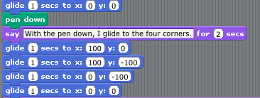
At some point while you’re testing your code, you’ll want to remove the pen marks on the Stage. To clear the pen marks, use the erase all block, which is under the Pen Menu.

Draw a Triangle
Let us turn our square into a house. To draw a roof on top of the house, we need to draw a triangle. We can pick a new color for the roof if we like. If we start at the upper left corner of the house, we need to figure out where the top center of the roof should be.

What should we pick?
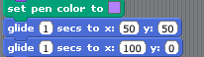

Draw a Tree
Pick a location on the Stage where you would like the tree. Glide there. What went wrong? You probably left a trail of ink behind you on the way! To avoid that, be sure to use pen up before you glide.

Draw the trunk of the tree in brown. How should you draw the leaves of the tree? One way is to make just a big pen blob at the top. To do this, use set pen size. What size would you like to try?

To make the pen show up in a different size, you’ll either need to move a little or bring the pen up and then pen down again.
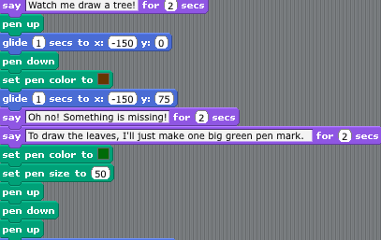

Draw a Circle
For our last part of the picture, let us draw a yellow sun. Pick a yellow color and a smaller pen size again.

Drawing a circle is more challenging than some of the other shapes. How could you tell your Sprite how to move in the shape of a circle? Imagine you have to walk in the shape of a circle, how would you do it?

The easiest way to move in the shape of a circle is to take a step and then turn a little bit; take another step and turn a little bit; and, do this over and over again. If you turn the right amount, at some point you’ll get back to where you started and you’ll have made a circle.

You can use the move 10 steps block and turn 15 degrees blocks, both under Motion to do this. Try these two commands together a bunch of times. Try putting them in a repeat block (under Control).
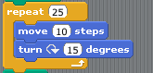

To make sure this is complete, start your stack of blocks with a When GreenFlag clicked. At the start, you’ll also probably want to erase all your pen marks and make sure the pen size is set how you want it.

We’re now done and it is your turn to draw whatever scene you like.

If you finish this project early, you might want to experiment with making a Sprite move around the Stage forever in surprising ways. Try changing the amount the Sprite moves and turns and changes pen colors!
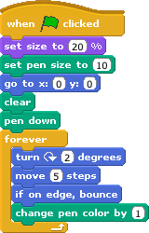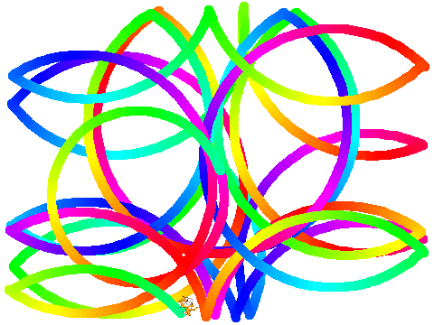

Things to Remember
In Scratch, the background is called the Stage. The stage is a lot like a sprite because it can have costumes and scripts too. To edit the stage, select it and click the Background tab.

There are many ways to move sprites. Gliding is one way to make movement very smooth and natural. The go to block moves a Sprite to a new position instantaneously.

Variables are extremely useful. Variables hold information about what has happened. Two examples of variables are the x and the y position of a sprite; the x position shows where a sprite is left to right while the y position shows where it is up and down. Every sprite has its own x and y variable.

The When Green Flag Clicked block will be activated whenever the user clicks on the green flag to start up a new game.

A useful trick to know is that Scratch fills in the values of the go to and glide blocks with the current (x, y) position of the Sprite when you click on the Movement Menu.
1