Stamp Art Lesson:
In this lesson, you will use Scratch to create crazy pictures with different costumes, graphic effects, stamps, backgrounds, and sound.
You will learn how to activate different scripts with different actions and how to generate random numbers.

http://scratch.mit.edu/projects/dusseau/2802049

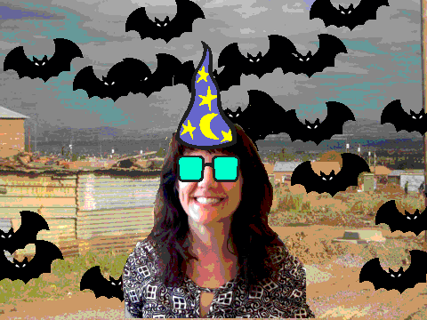
This lesson has four simple steps:
- Allow the user to change the graphic effects of a Sprite
- Place different costumes (e.g., hats, sunglasses) over the main Sprite
- Enable different backgrounds and add music
- Allow the user to add stamps to the background.

Graphic Effects of a Sprite
The first thing you’ll need to do is pick a character as the main Sprite for this project; your character should be a person, either shoulders-up or their whole body. The character should not have any background behind them; you may need to Edit their costume to Erase their background.

It is best if you are able to take a picture of yourself with a camera on your computer and save that (e.g., as a JPEG or PNG file). If this is not a possibility, the next best option is to find a picture of a person (e.g., a celebrity) on the Web. Then Import that into Scratch. The third best option is to draw a picture of a person using the Paint tools in Scratch. Create this Sprite by clicking on the Cat image in the lower right. Delete the old Cat sprite by clicking on its trashcan icon.

After you have a Sprite you like, see what type of graphic effects we can apply to that Sprite by writing code to control it. These initial blocks will be under the Looks category. Try out change color effect by 25. How does that make your Sprite look? You can try other graphic effects by clicking on the down arrow next to the word color in the block change color effect. For example, you can try change fisheye effect and change whirl effect.

To erase these effects and return your Sprite to normal, use the block clear graphic effects. (You can drag and drop these blocks into your work space or just click on them in the side bar.)

We want to create scripts such that someone using our program can control these effects without having to click on the instruction blocks. For example, in Presentation Mode, the user can’t see the instruction blocks to click on them. We need a different way to get these instruction blocks to run.

The way to activate, or run, a script is with a Events block with a curved edge. For example, we can activate the change color effect by 25 block with the When space key is pressed block. We can change the specific key that needs to be pressed. What would be a good key to control the color? (probably c) To control fisheye? (f) To control whirl? (w).

You’ll also need a way for the user to erase all of those effects and return to normal? When do you think a good time to do that would be?

Pro tips: You can duplicate stacks of blocks by Ctrl-Clicking on that stack. You can clean up your stacks by Ctrl-Clicking on the workspace surface.
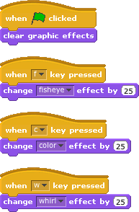

Costumes over the Sprite
We would now like to be able to decorate our person with different outfits or accessories. For example, you might like to put different hats or sunglasses on your person to see how they look that way. To do this, you will create one new Sprite with multiple Costumes.

As an example, lets say you want to try out new hats. First, create a new Sprite; use the search button to import a Sprite that was drawn by someone else.

Select the Fashion folder and then scroll down until you see the hats. Click on one you like and then Ok.

Position this Hat Sprite on the Stage so that it is on your Person Sprite’s head. You may want to change the size as well. You can do this either through the paint tool or with code (“change size by …”)

Once you are happy with the position, its time to try more hats. We want this Hat Sprite to have multiple Hat Costumes. We only want to show one hat at a time on our person, so we don’t want each hat to be its own Sprite; we want it to be just a Costume of the Sprite. To do this, select the Hat Sprite and click the Cat icon on the bottom left (in the Costumes tab). Import more pictures of hats as new costumes. When you are done, the costumes should look like this.
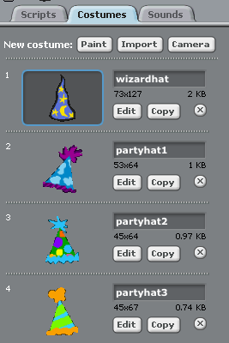

You may need to modify the costume images a bit to make sure you like the size and placement of each on your person. (Remember, code for a Sprite will apply to all the costumes of a Sprite.) To show the different costumes, you will use the next costume block under the Looks menu. How should you let the user control when a different hat is shown? Use When h key pressed.
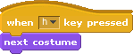
You can repeat this with different accessories. For example, you can create a new Glasses Sprite that will have multiple Glasses Costumes. The Glasses should be a new Sprite from the hat Sprite since you want each to be showing at the same time!

You will want to use a different key to activate each of the Sprites and the costumes they show! (For example, When g key pressed)

Background and Music
It is very easy to change the background in Scratch. In Scratch, the background is actually called the Stage. It works a lot like a sprite because it can have costumes, scripts, and sounds too. To edit the stage, you need to first select it.
Click the Backdrop tab on the right-middle. You can draw your own background or import one that is already made. Click the Import Button.

A window will pop up that will allow you to choose a background. Import a bunch of backgrounds that you think will look interesting behind your character. Remember to delete the initial blank one.

You can write code to control the backdrops. To switch between backgrounds, use the block next background. Choose a key for the user to press to activate this block.

You can liven up your project by having it play music in the background. Which Sprite should be the one playing the music? Since the music is associated with the whole project, it makes sense to put the scripts playing the music with the Stage.

Let’s look at the Sounds that are available to us. Click on the Sounds Tab next to Scripts and Backgrounds. Then click on Import. You will have many options; I like Chill, but you can pick anything you like.

You can now try the block play sound and select Chill. Let us activate that block when the Green Flag is clicked. What is the problem? We want the music to play forever. What goes wrong when you play the sound over and over again? Play sound will start up the music and then continue on to the next block; but, the next block is another play sound in the forever loop! So, Scratch just keeps starting more Chill recordings and you never get to hear them continue. To fix this, use the block play sound until done instead; this block plays the sound and waits until the recording is done before continuing on to the next block.

Stamps in the Background
Let us add a weird Sprite, like a bat, that shows up in a new place on the background whenever the user presses the space bar. Import a bat as a new sprite. Begin by making a script that tells the bat to go to random position when the space key is pressed. Each time the space key is pressed, the block will pick a different random position.

.

To make the behavior of your moving bat look more interesting, you can have it leave behind a trail of stamps as it moves. The Stamp block is an extension in Scratch 3.0. To add extensions to this project, click on the icon in the very lower left corner; then pick Pen extension. Under Pen, the stamp block stamps the current costume of the Sprite wherever that Sprite is; when you move the Sprite, you can then see the Stamp that it left behind.

To get rid of the stamps when they fill the stage, you can use the clear block.

Save your project under File. Make sure you can find it in your projects. Go back to your project and “Share” it so others can see it!

You should be all done now!

